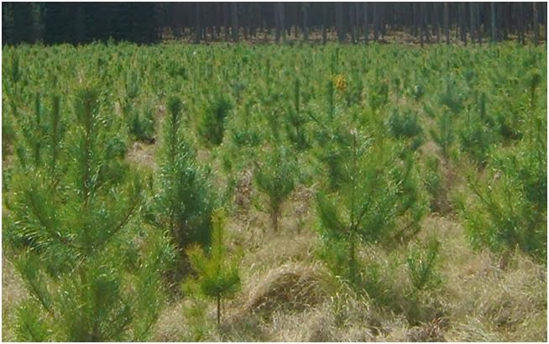

[This Photo](http://biology.stackexchange.com/questions/20679/why-do-pine-stands-exist) by Unknown Author is licensed under [CC BY-SA](https://creativecommons.org/licenses/by-sa/3.0/)